Landing, Login, and Enrollment Pages Development

Thomas Pedersen

University of Arizona Global Campus

CST 499: Capstone for Computer Software Technology

Professor Charmelia Butler

November 26, 2024

To run a PHP file in AMPPS, follow these steps:

The process of running a PHP file in AMPPS (Apache, MySQL, and PHP Server) is fairly straightforward. Here are the steps you need to follow:

1. Install AMPPS: First, you need to install AMPPS on your computer. You can download it for free from the official website.
2. Open AMPPS: Once you have installed AMPPS, you should open it. On the main screen of the application, you can find the "myPhpAdm" tab.
3. Create a new project: Click on the "Create New Site" button located in the "Wamp" tab.

Landing page: This is the first page that users will see when they visit your website. It should have a clear and concise description of your product or service, as well as a call-to-action (CTA) encouraging users to either log in or register. It could also include some key features or benefits of your product or service. Login page: This page would allow existing users to access their accounts. It would typically include a username and password field.

To create a MySQL database and tables in AMPPS, follow these steps:

1. Open the PHPMyAdmin tool in your AMPPS control panel.

2. Click on the Databases tab to create a new database.

3. Enter a name for the new database in the “Create new database” field.

4. Click the “Create” button.

5. Click on the Databases tab again to select the newly created database.

6. Click on the SQL tab.

7. In the SQL text area, write a SQL script to create the tables for your database.

I used MySQL functions such as `mysqli_connect()` and `mysql_query().` I implemented a database connection class with `$conn = new mysqli($servername, $username, $password, $db);` in the constructor and then used the `mysqli_real_escape_string()` function to sanitize user input when writing SQL queries to prevent SQL injection attacks. I used `mysqli_query()` to perform SQL operations such as data retrieval, insertion, and deletion.

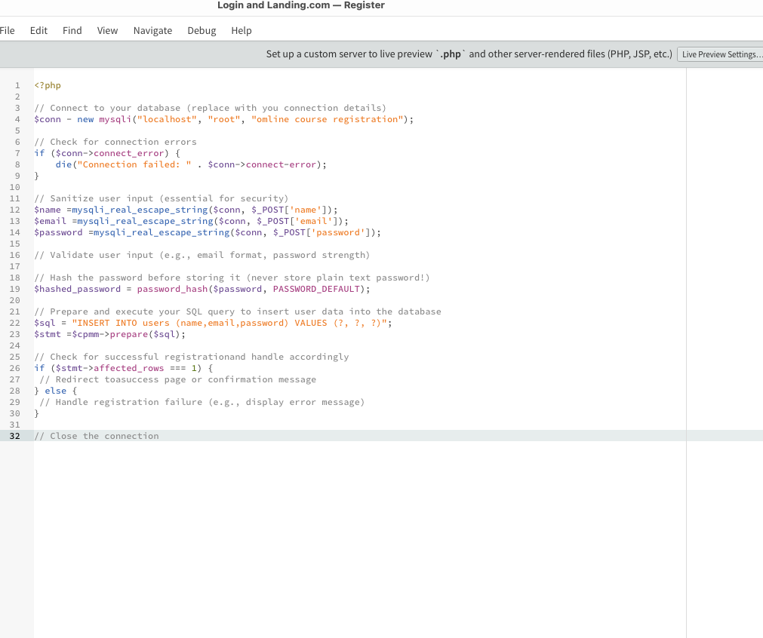

I have developed and added landing, login, and enrollment pages as part of a website project using AMPPS. The landing page provides users with an overview of the website, the login page enables registered users to access their accounts, and the enrollment page allows new users to create an account.

The development for each page includes building the front end with HTML, CSS, and JavaScript, as well as integrating the back end with PHP and MySQL via the AMPPS server. The design of each page is responsive to ensure it functions well on desktop and mobile devices. According to Chris Kolade, “Having a good landing page for your website is important. It can help drive customers to your site where they'll find your products and services and hopefully take action.” (Kolade, 2022) that is so very true about this and how we need to make a good home page and login page attract your client or customers to your site.

# Works Cited

Kolade, C. (2022, Jan 17). *Web Development Project – How to Make a Landing Page with HTML, CSS, and JavaScript*. Retrieved from Free Code Camp: https://www.freecodecamp.org/news/how-to-make-a-landing-page-with-html-css-and-javascript/